语言证书 （LC）

Candidate Guidelines考生指南
Online Exams with live Invigilation
实时监控的在线考试
A step by step Guide on how to take a LanguageCert Online Exam
手把手教你如何完成LC语言证书考试
Windows

System Requirements电脑系统配置要求
Ensure that your computer meets the following system requirements:请确保你的电脑系统配置达到以下要求
- Windows® 10 (Windows 10S is not supported)不支持windows10s, Windows® 8.1, Windows® 8, Windows® 7
- Windows® 10（不支持windows10s）, Windows® 8.1, Windows® 8, Windows® 7
- Internet Explorer version 10 or greater
- IE浏览器版本在10以上或者更高级的IE
- Dual-core 2.4GHz CPU or faster with 2GB of RAM (recommended)
- 双核2.4GHZ处理器或者更高级的RAM 2GM （推荐后者）
- Active Full-Time/Broadband internet connection of at least 4Mbps
- 连接至少4Mbps的稳定宽带
- 16-bit monitor (at least 15”) with screen resolution 1024 x 768 or higher
- 屏幕分辨率为1024 x 768或更高的16位显示器（至少15英寸）
- Keyboard and mouse or another pointing device
- 鼠标键盘或其他可点击设备
- A web camera (embedded or external). Make sure you can rotate your device when asked by the proctor
- 网络摄像头（嵌入式或外设）。用来确保在督导员询问时可以旋转设备
- Headsets with Microphone
- 带麦克风的耳机

Exam Preparation考试准备
Before you take the exam, you need to:在你参加考试前，你应该
- Have a valid Government issued Identification Document including a photograph and date of birth in English characters, such as a National ID card, Passport, driving license, military card or social security card, as your online proctor will need to verify your ID before you begin your exam.
- 拥有政府颁发的身份证明，其上包含照片和出生日期（英文），这些证明（除护照以外其余证件均须附带英文版）包括身份证、护照、驾照、军官证、社保卡，线上督导员会在你的考试开始前检查你的个人证明。
- Disable any Virtualization Software such as VMware, Virtual PC, Virtual Box or Sandbox during the exam. For exam security reasons, the ExamShield cannot run through any virtualization software. You should also close any applications that might affect the exam process, such as web browsers, chat, desktop, sharing and mail client applications
- 考试期间禁止使用任何虚拟化软件，如虚拟软件、虚拟电脑、虚拟机、沙盒。为了考试安全起见，ExamShield无法通过任何虚拟化软件运行。您还应该关闭任何可能影响考试过程的应用程序，例如Web浏览器，聊天，桌面，共享和邮件客户端应用程序。
- Make sure your mobile number is filled in your Candidate Profile.
- 确保在个人考试资料中填写个人手机号码

On the day of the exam, please ensure:考试当天，请注意确保
- You have your photo ID available
- 准备好带您照片的身份证件
- You can rotate your webcam 360 degrees
- 您的网络摄像头可以进行360度旋转
- You are the only person in the room throughout the exam session
- 考试期间屋内除您之外无其他人
- There is no background noise in the room
- 室内无其他背景噪音
- There is adequate light in the room, but no direct light towards the web camera
- 室内亮度足够，但没有光直接对着网络摄像头
- Your desk is clean, papers, books, dictionaries or notes are not allowed
- 您的桌子需要保证干净，没有纸张、书籍、字典和笔记。
- Use of blank papers for note-taking are only allowed for the Spoken exam. The proctor/interlocutor will ask you to tear the papers in front of the screen at the end of the test.
- 仅在口语考试时允许使用白纸记录笔记。督导员将会要求您在考试结束时将上述白纸在摄像头前撕碎。
- You have available headsets as they are required for the Listening and the Speaking part
- 准备好头戴式耳机，您将在听力和口语部分使用到它。
- Mobile phones should be set to silent and not deactivated. This way Customer Service can contact you in case of technical issues
- 手机应设置为静音且不能关机。如果发生技术问题，客户服务部可以通过电话与您联系
Please note:请注意
- Breaks are not allowed during the Exam session.
- 考试期间不允许任何中断
- Rooms with glass walls are not allowed
- 不允许使用有镜面墙的屋子
- If you experience difficulties in installing or executing ExamShield, please add ExamShield to your Antivirus and Firewall whitelist and repeat the above steps. Please consult your Antivirus/Firewall vendor on how to do this.
- 如果您在安装或运行ExamShield时遇到困难，请将ExamShield添加到杀毒软件和防火墙的白名单中，然后重复上述步骤。请咨询您的杀毒软件/防火墙供应商，以了解如何执行此操作。
- Corporate networks might impact the service delivery. You are advised to consult your IT department.
- 如出现因网络引起的故障，建议咨询您的IT部门。
- After finishing your exam, you are strongly advised to uninstall ExamShield. If you are planning to take another exam, you will receive a new link with instructions on how to reinstall the ExamShield.
- 完成考试后，强烈建议您卸载ExamShield。如果您打算参加另一场考试，您将收到一个新链接，其中包含有关如何重新安装ExamShield的说明。
- You should always install the ExamShield version provided to you for your exam. If you try to use an older version of ExamShield already installed in your computer, an error will appear prompting you to update to the latest version.
- 您应始终安装为您考试提供的ExamShield版本。如果您尝试使用计算机中已安装的ExamShield的旧版本，则会出现错误提示，并让您更新到最新版本。
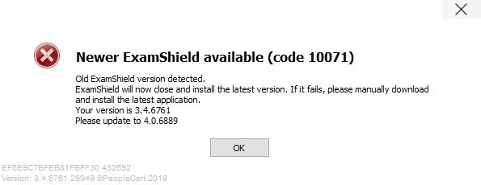

Exam Shield Installation安装Exam Shield

Up to 1 Hour prior to the exam
请至少在考试前一小时完成
Step 1: Install the ExamShield第一步，安装ExamShield
An email will be sent to you 24hours prior to the exam with a link to download the ExamShield.
考试前24小时，我们将向您发送一封电子邮件，其中包含下载ExamShield的链接。
- Close all applications running in your computer关闭您电脑上运行的所有应用  - Disable any Virtualization Software任何虚拟软件都不能使用  Click on the link included in the PeopleCert registration email and “Accept and Install” to set up the ExamShield application.  点击PeopleCert注册电子邮件中所包含的链接，点击“Accept and Install”来设置ExamShield应用程序。 | 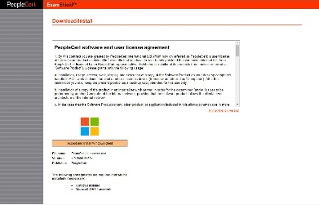
Click Save/Run ExamShieldLauncher.exe.The installation should start automatically and may take a few minutes to complete.  单击“Save/RunExamShieldLauncher.exe”。安装将自动开始，这个过程可能需要几分钟才能完成。 | 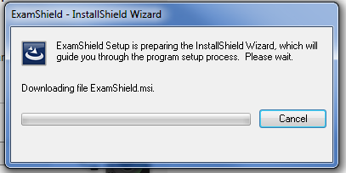
Once installation is completed, a new window will appear. Please note that the candidate number and the examination pin are already filled in with your details, so you just have to proceed with the “Check System” and take the exam.  安装完成后，将会弹出一个新窗口。请注意，您的考生编号和考试密码等详细信息已经被填写好了，因此您只需要继续执行“Check System”并参加考试即可。  A countdown timer to your exam will appear under your exam credentials.  考试倒数计时器将显示在您的准考证下。  “Call” button will re-direct you to the phone number that you could contact Customer Support.  “Call”按钮会将您重新定位到客户支持部的联系号码。  “Chat” button will re-direct you to the chat that you could contact Customer Support.  “Chat”按钮会将您重新定位到与客户支持部的聊天。 | 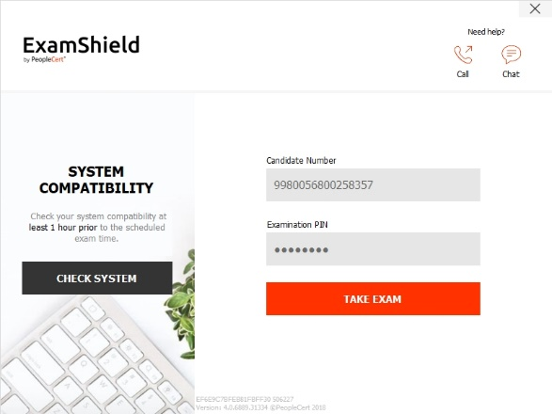
Click “CHECK SYSTEM” to confirm your system meets the Exam Shield requirements. Do this at least 1 hour prior to the scheduled exam time, in order to avoid last minute technical issues.
单击“CHECK SYSTEM”以确认您的系统符合Exam Shield要求。为了避免出现最后的技术问题，请至少在计划的考试时间之前1小时执行此操作。
Compatibility test consists of 4 parts which are:
兼容性测试包括4个部分：
- System integrity
- Audio
- Camera
- Internet connection
- 系统完整性
- 音频
- 相机
- 网络连接

- System integrity系统完整性  System Integrity checks the compliance of your Operating System with the ExamShield application requirements, such as the OS version and free disk space amongst others.  系统完整性将检查您的操作系统与应用ExamShield要求是否符合，如操作系统版本和可用磁盘空间。  - Audio音频  In order to check audio, select “BEGIN AUDIO TEST”.  为了检查音频，请选择“ BEGIN AUDIO TEST”。  Your microphone will start recording for the next 10 seconds.  您的麦克风将在接下来的10秒钟内开始录音。  ExamShield will playback the recording. After the end of the 10’’ playback, if you can hear your voice clearly, select “YES” to proceed to the next checks. If not, select“NO” to run the audio test again.  ExamShield将回放录音。 10秒录音播放结束后，如果您可以清楚地听到声音，请选择“YES”以继续进行下一步检查。如果不是，请选择“NO”以再次运行音频测试。  - Camera 相机  In order to check that your camera is functional, you will be asked to see if you can see yourself in a specific panel. You will be able to edit the Settings of your camera by selecting the relative button next to the Camera dropdown menu.  为了检查您的相机是否可以正常工作，系统会要求您检查是否可以在特定面板中看到自己。通过选择“相机”下拉菜单旁边的相关按钮，您可以编辑相机的设置。  After completing each check, a message informs you on whether the check has “Passed” or “Failed”, or even provide you with a “Warning”notification.  完成每项检查后，将显示一条消息，通知您该项检查是“Passed”还是“Failed”，甚至向您提供“Warning”通知。  In case of “Failed”, detailederror informationand possible workarounds will be provided.  Click “CHECK AGAIN” to retry.  如果出现“Failed”，将提供详细的错误信息和可能的解决方法。  单击“CHECK AGAIN”重试。  In case of warning, click on the arrow on the right of the warning to view more details  如果出现警告，请单击警告右侧的箭头以查看更多详细信息  After a successful check of each step, you will be able to click on the“START EXAM” button, if the scheduled exam start time is in less than 10 minutes.  如果距离计划考试开始时间少于10分钟，则在成功检查完每个步骤后，您可以单击“START EXAM”按钮。  Otherwise you are suggested to terminate the application and launch it again 10 minutes prior to your scheduled exam time.  否则，建议您终止应用程序并在计划的考试时间之前10分钟再次启动它。  By clicking on Exam guidelineslink on the bottom of the screen, you will be informed about all appropriate information so as to run your online proctored exam.  通过单击屏幕底部的考试指南链接，您将被告知所有适当的信息，以便进行在线监督式考试。 | 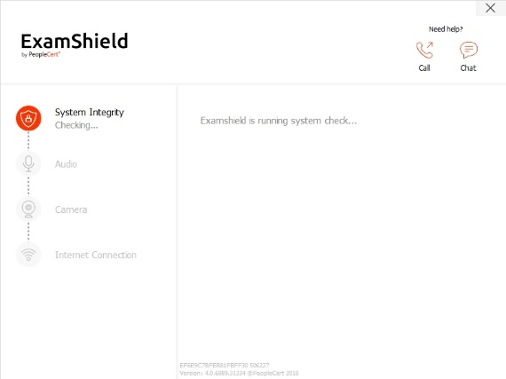  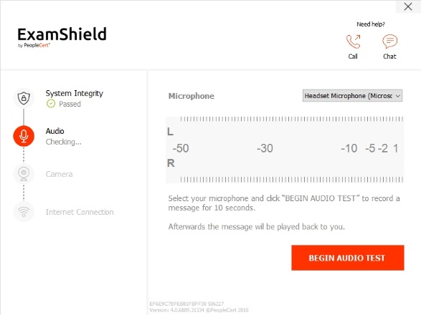  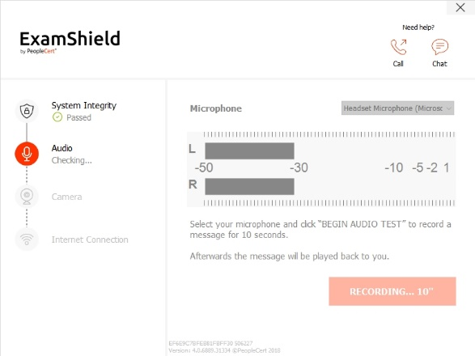  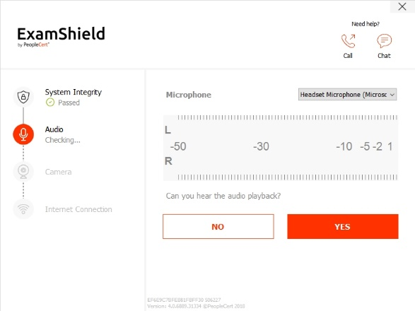  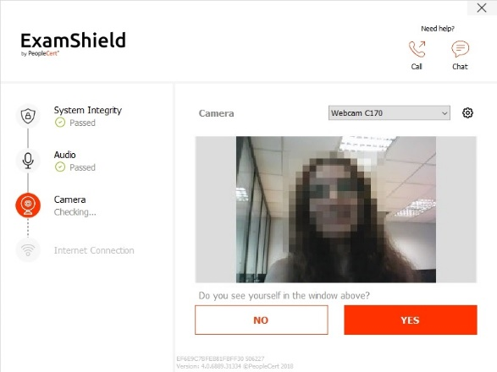  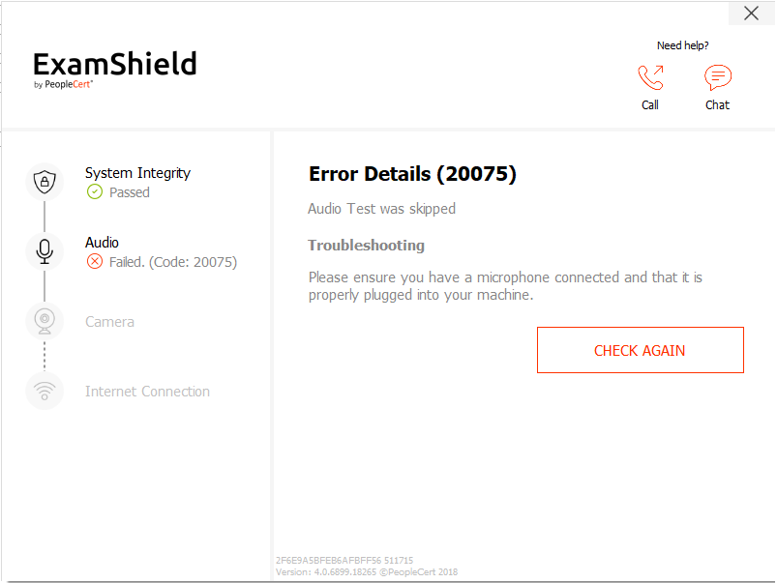  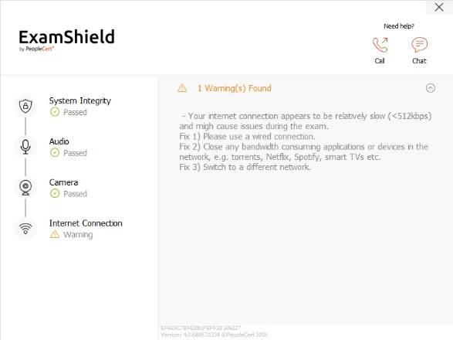  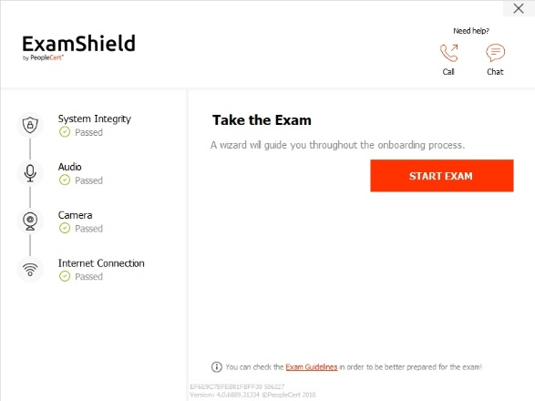  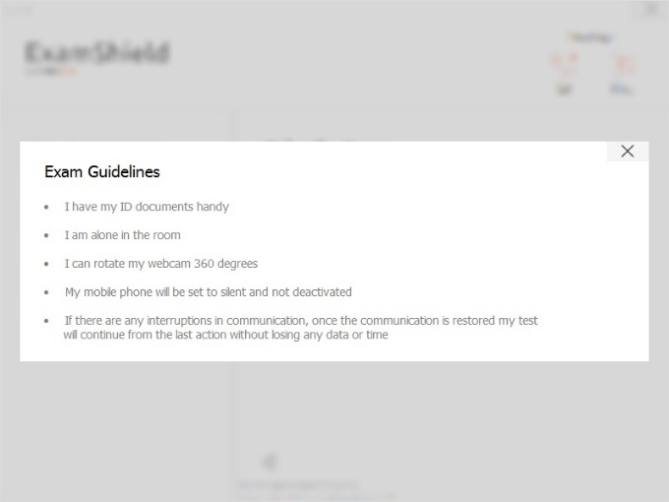
10 Minutes prior to the exam
考试前10分钟
Step 2: Log In to ExamShield 第二步：登录ExamShield  Double click the ExamShield icon from your desktop and click “TAKE EXAM” to login.  双击桌面上的ExamShield图标，然后单击“TAKE EXAM”进行登录。  A pop-up message will notify you if any application needs to be closed to continue with the exam.  如果需要关闭任何应用程序以继续考试，则会弹出一条消息通知您。  Step 3: Self-onboarding 第三步：个人考试须知  An intuitive wizard will guide you towards connecting to your proctor and starting your exam.  直观的指引将指导您连接至监考人员并开始考试。  - Accept NDA接受保密协议  After reading the Non-Disclosure Agreement and Terms of Use, click on “Next” to accept them and proceed with the test.  阅读保密协议和使用条款后，单击“Next”接受它们并继续进行考试。  Click on “End Exam” if you do not accept the terms and wish to end the test. You cannot continue with the test unless you accept the terms of use.  如果您不接受条款并希望结束考试，请单击“End Exam”。除非您接受使用条款，否则无法继续考试。  - Read exam instructions阅读考试说明  Read the information carefully before you proceed to the next step. Make sure that you scroll the bar down, to read the rest of the instructions.  在继续下一步之前，请仔细阅读信息。确保向下滚动条以阅读其余说明。  - View Exam Tutorial查看考试指南  A quick tutorial will help you familiarize with the exam environment. You will learn how to:  快速教程将帮助您熟悉考试环境。你将学到如何：  - navigate among questions如何前往各个问题  - flag a question标记问题  - end an exam结束考试  - zoom in or zoom out the exam environment放大或缩小考试环境  - How to refresh and login in case of a network disconnection如何刷新和登录如果出现网络问题  - Communicate with your proctor through chat与你的督导员交谈  To navigate through the tutorial, please use the orange arrows at the right and left side of the grey area.  要浏览本教程，请使用灰色区域右侧和左侧的橙色箭头。  - Check exam rules检查考试规则  Check all the rules confirming that you have read and approved all of them (ensure you scroll down with the bar).  检查所有规则以确认您已阅读并批准所有规则（确保向下滚动条）。  - Scan your ID扫描您的身份证明  You can either upload your ID Document or take a picture of it, so that PeopleCert can verify your personal information.  您可以上传您的身份证件或对其进行拍照，以便PeopleCert可以验证您的个人信息。  If you prefer uploading it, select “BROWSE”and locate a picture of your ID.  如果您选择上传，请选择“BROWSE”并找到您的证件照。  Select “CAPTURE”in order to take a snapshot of your ID. Make sure you get a clear and readable snapshot.  选择“CAPTURE”以拍摄您的ID的快照。确保获得清晰易读的快照。  In case of “CAPTURE”, you are able to accept the picture or retry to take another one or to cancel it.  在“CAPTURE”的情况下，您可以接受照片或重试拍摄另一张照片或将其取消。  If you are not satisfied by the clarity of thesnapshots, feel free to proceed with your best shot and your proctor will assist you once connected.  如果您对快照的清晰度不满意，请随时进行最佳拍摄，而督导员将在连接后为您提供帮助。  - Connect to proctor连接到督导员  Once you complete the above steps, click “LET’S GO” to connect with your proctor.  完成上述步骤后，点击“LET’S GO”与您的监考老师联系。 | 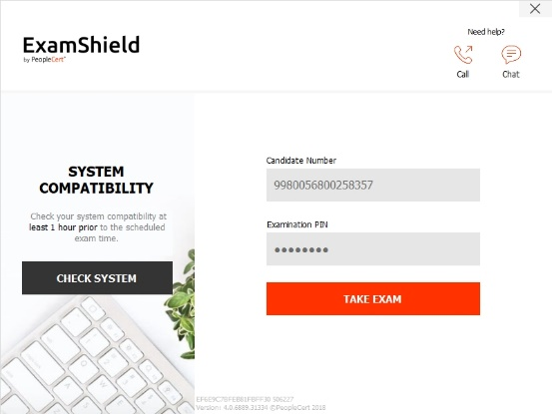  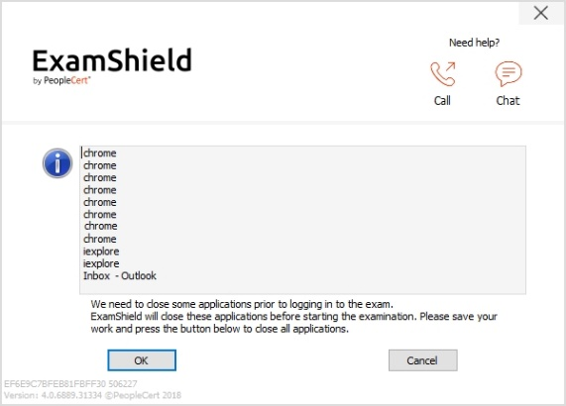  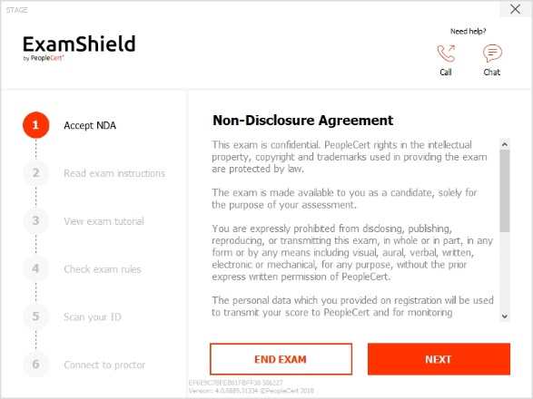  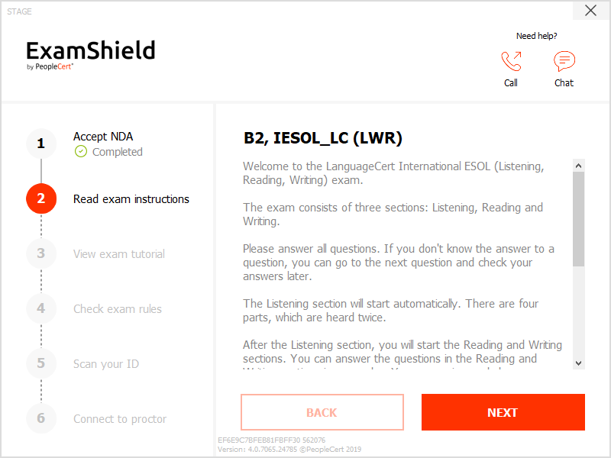  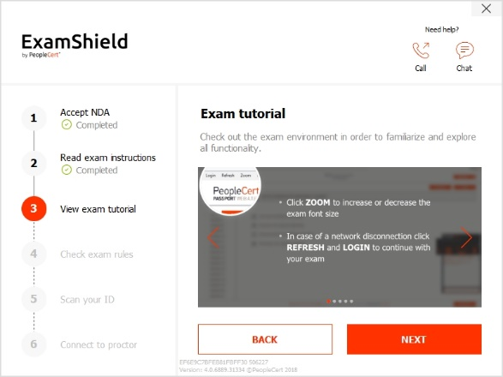  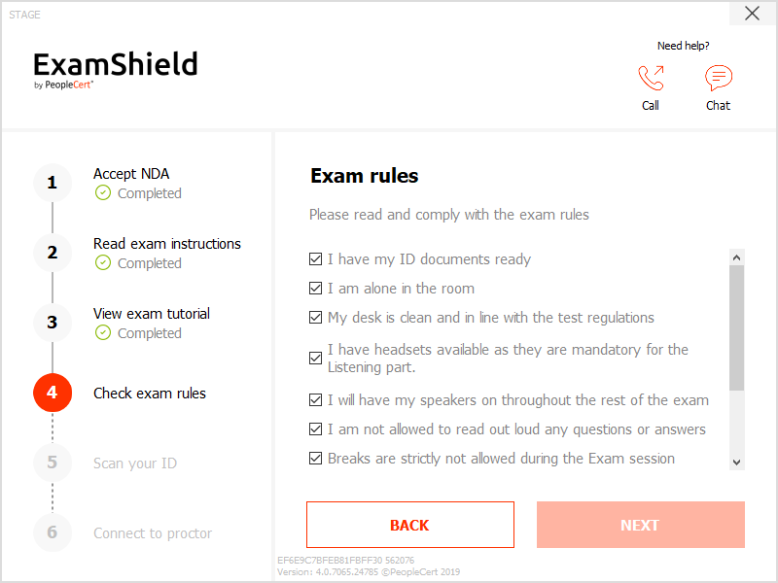  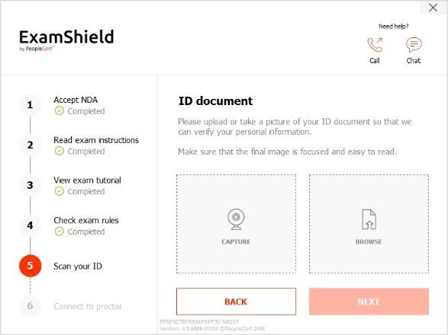  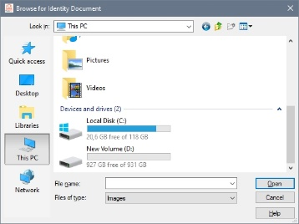  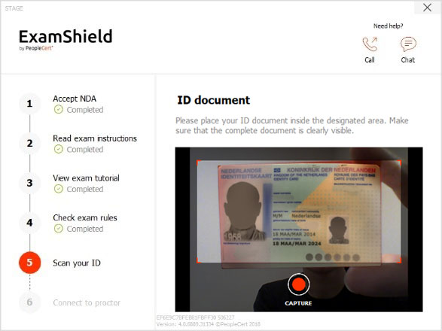  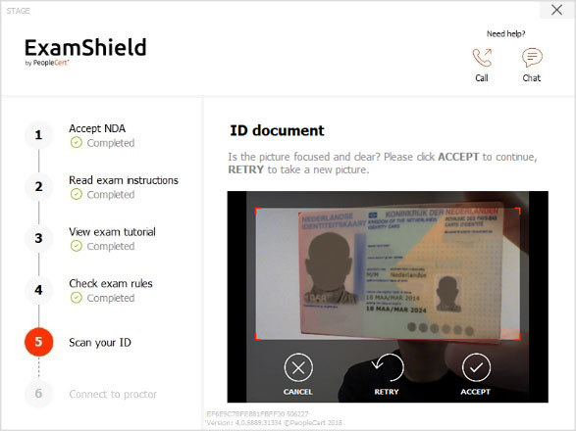  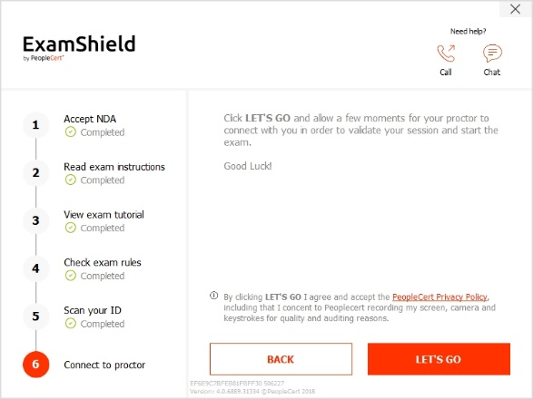
Once logged in, the following control panel will open:
登录后，将打开以下控制面板：
Many2Many control panel on the right, indicating you have successfully joined the session. You can minimize the control panel by clicking on the red arrow button.  右侧的Many2Many控制面板，指示您已成功加入会话。您可以通过单击红色箭头按钮最小化控制面板。 | 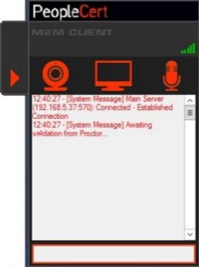
Step 4: Your online proctor joins the session您的在线督导员参加了会议

Please Note: For the Speaking exam, the Interlocutor will assume the role of the proctor.
请注意：对于口语考试，对话者将担任督导员的角色。

You will be instructed to: 我们将指导您：
- Check your audio and video performance
- 检查您的音频和视频性能
- Showyour ID to the camera if needed
- 如果需要，将您的ID显示在相机上
- Show your room (360⁰ camera rotation)and your desk
- •显示您的房间（360度相机旋转）和办公桌
- Confirm your personal details. If any of the information is incorrect, please inform your online proctor
- 确认您的个人资料。如果任何信息不正确，请通知您的在线督导员
- Your online proctor will let you know when you are set to begin your exam!
- 您的在线督导员将在您准备开始考试时通知您！

Click Next to continue only when prompted by your Proctor.
在督导员提示时单击下一步继续。

Please note:请注意
- Extensive room and body check might be needed based on proctor’s judgement. Thus, you might be requested to provide a close up view of your ears and hair and remove any scarf, hat, turban, kippah etc.
- 根据督导员的判断，可能需要进行大量的房间和身体检查。因此，可能会要求对您进行耳朵和头发的近距离观察，并去除任何围巾，帽子，头巾，圆帽等。
- An Online Proctor will be monitoring live the overall exam and be available throughout your exam session in case you need any help. You must have your microphone on throughout the session. In case of communication loss during the exam, the Online Proctor will stop the process. Once the connection is re-established, you will be able to continue your exam using your remaining exam time.
- 在线督导员将实时监控整个考试，并在整个考试期间为您提供帮助。在整个会话过程中，您必须打开麦克风。万一考试期间通信中断，在线督导员将停止考试。重新建立连接后，您将可以使用剩余的考试时间继续考试。
- Your exam session will be recorded for quality and auditing purposes.
- 为了质量和审核等目的，您的考试时间将被记录。

